Reaching Out in Love

“Be wise in the way you act toward outsiders; make the most of every opportunity.” ––Colossians 4:5

I would like to invite you to get comfortable and spend the next few minutes reading the true story that follows. It’s a story about those things which are most important in life –– God, people and where will we spend eternity. I share this story with you in the hopes that it will encourage you not to give up on the ‘Tommys’ in your life. There will be no greater thrill in heaven than knowing there are people there because you reached out in love.

Serving Him with you,

Pastor Dennis Starr

Rev. John Powell, a professor at Loyola University in Chicago writes about a student in his Theology of Faith class named Tommy…

“Some twelve years ago, I stood watching my university students file into the classroom for our first session in the Theology of Faith. That was the day I first saw Tommy. My eyes and my mind both blinked. He was combing his long flaxen hair, which hung six inches below his shoulders. It was the first time I had ever seen a boy with hair that long. I guess it was just coming into fashion then. I know in my mind that it isn't what's on your head but what's in it that counts; but on that day, I was unprepared and my emotions flipped. I immediately filed Tommy under "S" for strange... very strange.

“Tommy turned out to be the "atheist in residence" in my Theology of Faith course. He constantly objected to, smirked at, or whined about the possibility of an unconditionally loving Father/God. We lived with each other in relative peace for one semester, although I admit he was for me at times a serious pain in the back pew. When he came up at the end of the course to turn in his final exam, he asked in a cynical tone, "Do you think I'll ever find God?" I decided instantly on a little shock therapy. "No!" I said very emphatically. "Why not?" he responded, "I thought that was the product you were pushing." I let him get five steps from the classroom door and then called out, "Tommy! I don't think you'll ever find Him, but I am absolutely certain that He will find you!" He shrugged a little and left my class and my life.

“I felt slightly disappointed at the thought that he had missed my clever line: "He will find you!" At least I thought it was clever. Later, I heard that Tommy had graduated and I was duly grateful.

“Then a sad report came. I heard that Tommy had terminal cancer. Before I could search him out, he came to see me. When he walked into my office, his body was very badly wasted and the long hair had all fallen out as a result of chemotherapy. But his eyes were bright and his voice was firm, for the first time, I believe. "Tommy, I've thought about you so often –– I hear you are sick", I blurted out. "Oh, yes, very sick. I have cancer in both lungs. It's a matter of weeks." "Can you talk about it, Tom?" I asked. "Sure, what would you like to know?" he replied. "What's it like to be only twenty-four and dying?” I asked. "Well, it could be worse,” he replied. "Like what?” I asked. "Well, like being fifty and having no values or ideals; like being fifty and thinking that booze, seducing women, and making money are the real biggies' in life," he replied. I began to look through my mental file cabinet under 'S' where I had filed Tommy as strange. (It seems as though everybody I try to reject by classification, God sends back into my life to educate me). "But what I really came to see you about," Tom said, "is something you said to me on the last day of class." (He remembered!) He continued, "I asked you if you thought I would ever find God and you said, 'No!' which surprised me. Then you said, 'But He will find you.' “I thought about that a lot, even though my search for God was hardly intense at that time." (My clever line. He thought about that a lot!) "But when the doctors removed a lump from my groin and told me that it was malignant, that's when I got serious about locating God. And when the malignancy spread into my vital organs, I really began banging bloody fists against the bronze doors of heaven. But God did not come out. In fact, nothing happened. Did you ever try anything for a long time with great effort and with no success? You get psychologically glutted, fed up with trying. And then you quit. Well, one day I woke up, and instead of throwing a few more futile appeals over that high brick wall to a God who may be or may not be there, I just quit. I decided that I didn't really care about God, about an after life, or anything like that. I decided to spend what time I had left doing something more profitable. I thought about you and your class and I remembered something else you had said: ‘The essential sadness is to go through life without loving but it would be almost equally sad to go through life and leave this world without ever telling those you loved that you had loved them.' So, I began with the hardest one, my Dad. He was reading the newspaper when I approached him. “Dad." "Yes, what?", he asked without lowering the newspaper. "Dad, I would like to talk with you." "Well, talk." "I mean… it's really important." The newspaper came down three slow inches. "What is it?" "Dad, I love you––I just wanted you to know that." Tom smiled at me and said it with obvious satisfaction, as though he felt a warm and secret joy flowing inside of him. "The newspaper fluttered to the floor. Then my father did two things I could never remember him ever doing before. He cried and he hugged me. We talked all night, even though he had to go to work the next morning. It felt so good to be close to my father, to see his tears, to feel his hug, to hear him say that he loved me. It was easier with my mother and little brother. They cried with me, too, and we hugged each other, and started saying real nice things to each other. We shared the things we had been keeping secret for so many years. I was only sorry about one thing –– that I had waited so long. Here I was, just beginning to open up to all the people I had actually been close to. Then, one day I turned around and God was there. He didn't come to me when I pleaded with Him. I guess I was like an animal trainer holding out a hoop: 'C'mon, jump through! C'mon, I'll give you three days, three weeks.' "Apparently God does things in His own way and at His own hour. But the important thing is that He was there. He found me! You were right. He found me even after I stopped looking for Him."

"Tommy", I practically gasped: "I think you are saying something very important and much more universal than you realize. To me, at least, you are saying that the surest way to find God is not to make Him a private possession, a problem solver, or an instant consolation in time of need, but rather by opening to love. You know, the Apostle John said that. He said: 'God is love, and anyone who lives in love is living with God and God is living in him.' "Tom, could I ask you a favor? You know, when I had you in class you were a real pain. But (laughingly) you can make it all up to me now. Would you come into my present Theology of Faith course and tell them what you have just told me? If I told them the same thing it wouldn't be half as effective as if you were to tell it." "Ooh, I was ready for you, but I don't know if I'm ready for your class." "Tom, think about it. If and when you are ready, give me a call."

“In a few days, Tom called, said he was ready for the class, that he wanted to do that for God and for me. So we scheduled a date. However, he never made it. He had another appointment, far more important than the one with me and my class. Of course, his life was not really ended by his death, only changed. He made the great step from faith into vision. He found a life far more beautiful than the eye of man has ever seen or the ear of man has ever heard or the mind of man has ever imagined.

“Before he died, we talked one last time. "I'm not going to make it to your class", he said. "I know, Tom." "Will you tell them for me? Will you tell the whole world for me?" "I will, Tom. I'll tell them. I'll do my best."

“So, to all of you who have been kind enough to read this simple story about God's love, thank you for listening. And to you, Tommy, somewhere in the sunlit, verdant hills of heaven –– I told them, Tommy. as best I could.

“If this story means anything to you, please pass it on to a friend or two. It is a true story and is not enhanced for publicity purposes.

With thanks,

Rev. John Powell,
Professor,
Loyola University


Begins
Wednesday, September 10th
5:00 p.m. – 6:30 p.m.



Sunday, September 7th
9:15 a.m.
Our Rally Day Kick Off is all set for Sunday, September 7th. The children will be involved in the 10:30 service, followed by a pizza lunch. Please plan on attending and inviting friends.
Wednesday night programs will begin on September 10th. Supper will be at 4:30 p.m. Then we will break into our two classes: Jesus & Co. and Lighthouse Kids from 5:00 – 6:00 p.m. The new children’s choir, “Kids Praise” will meet from 6:00 – 6:30 p.m.
I would like to thank Miss Sandy, Miss Laura, Miss Michelle, Miss Becky, Miss Nadine, Miss Nicole, Miss Tamera and Miss Linnea for volunteering their time this year to make our Children’s Ministry programs so successful at Holy Emmanuel.
May God bless another year of kids at Holy Emmanuel.

In His Service,
Natalie Mylander


Sunday, September 7th
9:00 a.m. – 1:00 p.m.

Youth
Our youth group will kick the year off with our annual car wash on Rally Day, Sunday, September 7th, from 9:00 a.m. – 1:00 p.m. We need all 3rd – 12th graders and some adults to help. We will need rags, buckets, soap, etc. Our funds will be used for social activities this year.
We will be meeting the last Friday of every month for pizza, Bible study and an activity. Our first time will be Friday, September 26th, at 6:00 p.m. Please invite your friends and join us for good Christian fun!
My prayer for you is that your year at school is blessed with friends, good health and great teachers. Don’t forget to pray everyday – it will help you get through those hard times.
Don’t forget to worship every week! See you in church!

In His Name,
Natalie Mylander

Open Arms

News

Tuesday, September 2nd is our fall kick-off date. The center was closed on Friday, August 29th, so the teachers could get their rooms cleaned and ready for the kids. We pray this will be another God-blessed year for Open Arms.
Our field trip for September will once again be to the Apple Orchard.
We still have chapel every Wednesday morning at 9:30 a.m. and would like to invite everyone to join us some Wednesday to worship with the children. You are welcome!
As we enter our 11th year of being open, I want to acknowledge our teachers who have been at Open Arms five years or more. CONGRATULATONS, and thank you for your dedication to bringing Jesus into children’s lives:

Darlene Gerlach – 11 years
Anne Vinge – 11 years
Joel Grant – 10 years
Becky Batchelder – 5 years
Natalie Mylander – 5 years

As it says in the book of Mark, “Jesus said, ‘Let the little children come unto Me.’ “ That is our goal this year – that every one who comes in the doors of Open Arms will know Jesus as their personal Savior.

Working in His Kingdom,
Natalie Mylander

The New School Prayer
This was written by a teen in Bagdad, Arizona. This is incredible!

Now I sit me down in school
Where praying is against the rule
For this great nation under God
Finds mention of Him very odd.

If Scripture now the class recites,
It violates the Bill of Rights.
And anytime my head I bow
Becomes a Federal matter now.
Our hair can be purple, orange or green,
That’s no offense; it’s a freedom scene.
The law is specific, the Law is precise,
Prayers spoken aloud are a serious vice.
For praying in a public hall
Might offend someone with no faith at all.
In silence alone we must meditate,
God’s name is prohibited by the state.

We’re allowed to cuss and dress like freaks,
And pierce our noses, tongues and cheeks.
They’ve outlawed guns, but FIRST the Bible.
To quote the Good Book makes me liable.
We can elect a pregnant Senior Queen,
And the ‘unwed daddy,’ our Senior King.
It’s “inappropriate” to teach right from wrong,
We’re taught that such “judgments” do not belong.

We can get our condoms and birth controls,
Study witchcraft, vampires and totem poles.
But the ten Commandments are not allowed,
No word of God must reach this crowd.

It’s scary here I must confess,
When chaos reigns the school’s a mess.
So, Lord, this silent plea I make:
Should I be shot; My soul please take!

Amen.


Sunday Morning Bible Study
9:15 a.m. – 10:15 a.m.
Begins September 7th
- Master Plan (Led by Pastor Starr in the Chapel).
- Growing Through Life’s Challenges (Led by Randy Marko in the Accounting Room).

1st & 3rd Sunday Evenings
5:30 p.m.
Couples in Christ
Begins September 21st
- Topic to be Announced

3rd Monday Evenings
5:30 p.m. – Supper
6:00 p.m. – Bible Study
Begins September 15th
- Parenting Class – “Discipline” (Led by Randy Marko)

Tuesday Mornings
10:00 a.m.
Begins September 23rd
- The Book of Joshua (Led by Pat Squires at the Gables Apt. Bldg.)

Wednesday Mornings
Begins September 10th
9:30 a.m.
- Bad Girls of the Bible (Led by Candy Frein in the Accounting Room)

Thursday Mornings
10:00 a.m.
(Begins in October)
- Topic to be Announced (Led by Chuck Squires in the Accounting Room)

1st Friday Evenings
6:00 p.m.
Begins September 5th
- Ladies Bible Study
Join us at the home of Carol Starr for dessert and Bible Study.

4th Friday Evenings
6:00 p.m.
Begins September 26th
- Youth Bible Study (3rd-12th Graders)
Pizza, Bible Study, Fellowship

“Growing Through Life’s Challenges”
We all face similar challenges in life today, from rejection to depression, over whelming responsibilities to doubt. Many heroes of the Scriptures have shared the pains, disappointments and hopes that are common to modern day believers.
Those like Moses, Joshua, Daniel, Peter and Paul brought their fears and frustrations to God, we can learn to do the same. Filled with encouragement and truth, this study will remind us that God’s character and presence can give you strength to face any difficulty.
Won’t you please join us on Sunday mornings in the accounting room starting September 7th?
Parenting Class & Study Group
Parenthood is one of the most challenging and rewarding experiences most of us will ever have! But in the middle of busy days, runny noses and carpooling, we sometimes forget to enjoy the journey.
Dr. James Dobson, founder of Focus on the Family, has some answers, insight and solutions to one of the biggest challenges every parent encounters: discipline.
Our video-based study, "Essentials of Discipline: features the most up-to-date research on parenting, humorous animated vignettes, "mom (and dad) on the street" interviews and the kind of practical, approachable teaching that can only come from America's most trusted authority on parenting issues, Dr. James Dobson.
As we view and discuss the "Essentials of Discipline" videos, you'll gain the practical understanding, dynamic Biblical principles, and encouragement you need to shape your child's will without breaking his or her spirit, and feel confident in your ability to handle discipline in a positive way.
Won't you please join us on the third Monday evening of every month for a light supper at 5:30 p.m. and a study session beginning at 6:00-6:15 p.m.? Our first class meeting will be September 15th.

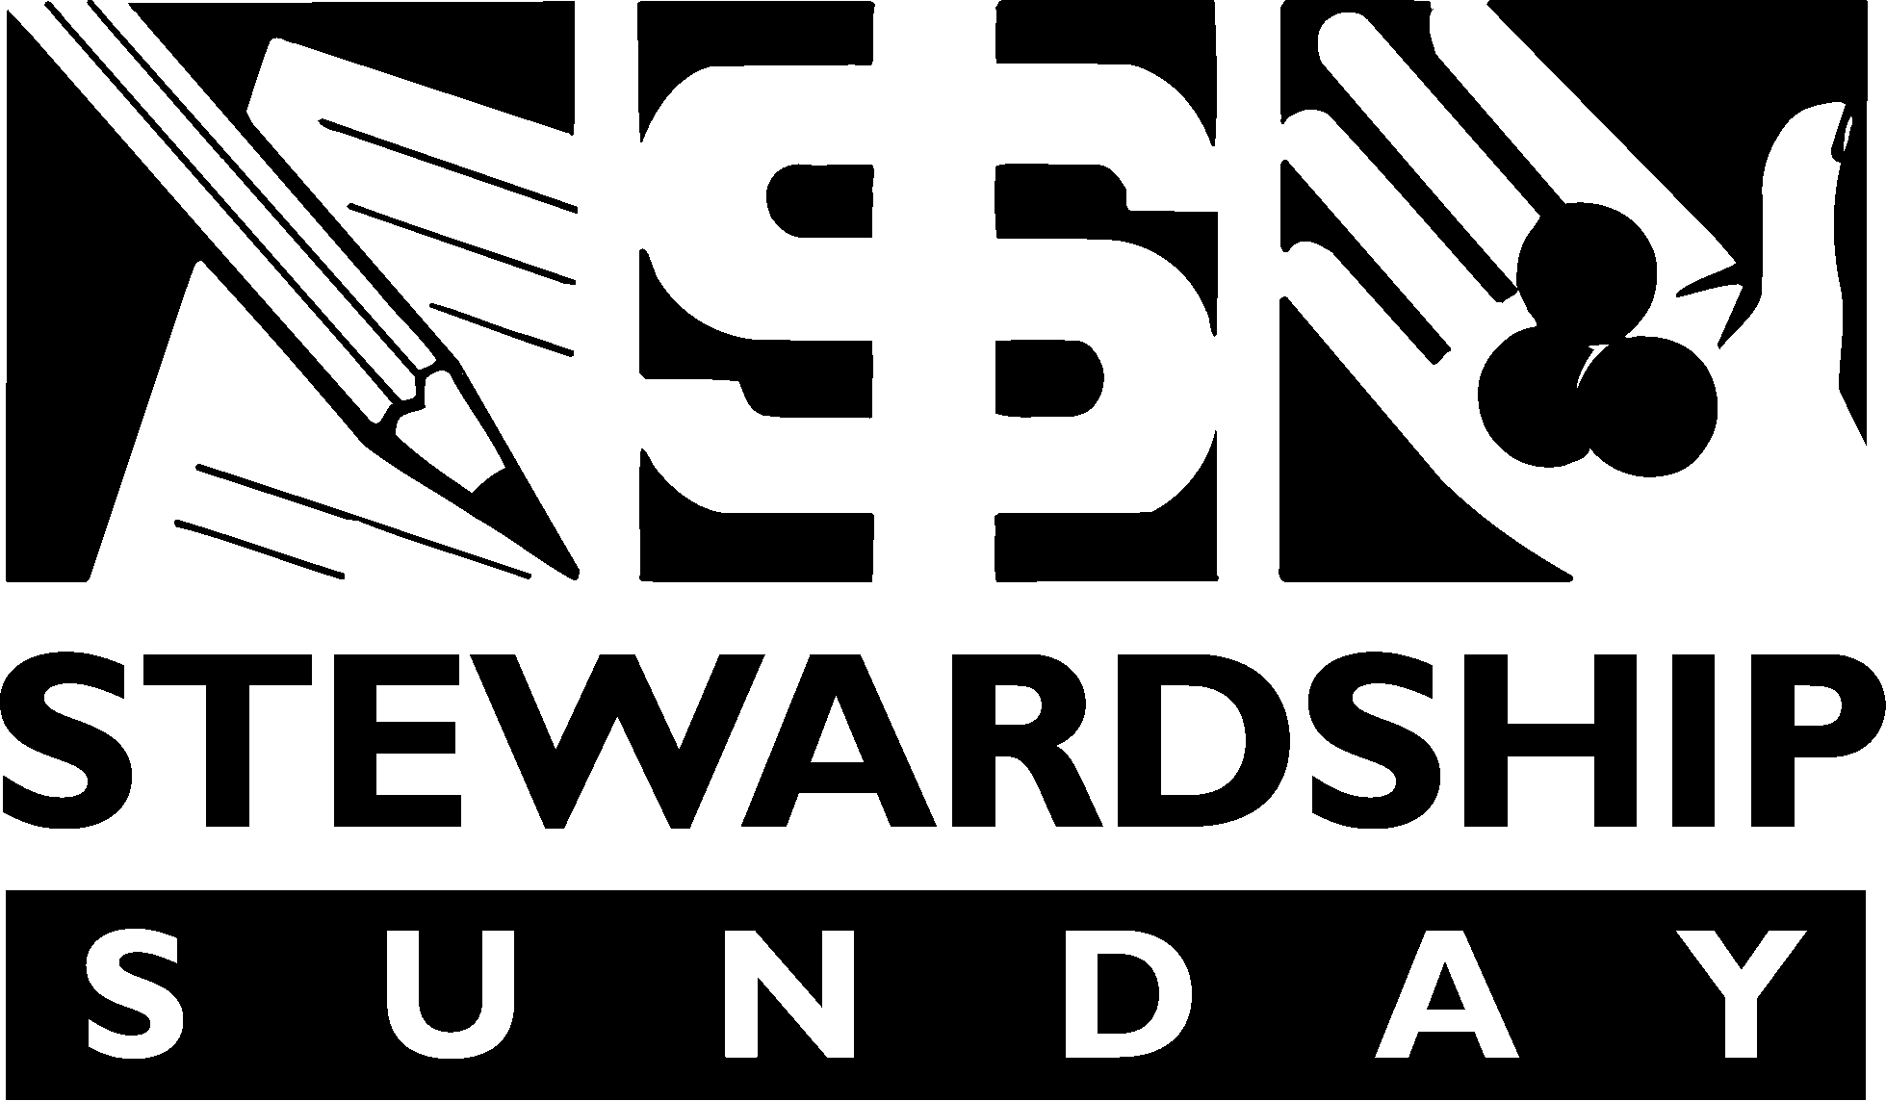
October 12, 2008
(Watch for more details in upcoming bulletins and the October Announcer.)


Sunday, September 21st
10:30 a.m. Worship Service
Be sure to join the members of Holy Emmanuel on the 21st as they welcome into membership:
Bea Brockman
Dale & Shirley Wold

New Members Night at the Dome
Tuesday, August 19th the group attended a Minnesota Twins game. They were part of the over 7000 Lutherans who attended Thrivent night at the Dome and watched the Twins defeat the Oakland Athletics by a score of 13 - 2. John & Sandy Carlson organized the event as part of the Outreach Board. Keep watching the Announcer for the next fun event.

Choir Rehearsal Begins
Sunday, September 28th
11:30 a.m.
The Chancel Choir will begin rehearsals on September 28th.
We invite anyone who is interested to be sure to join us!
News from the Board of Church Properties

Parking Lot Islands
We would like to thank everyone who helped work on the islands. We had 15 – 20 people that put in a great effort and we were able to get done all that we had planned for the day. Plus, we were able to work on several other areas that needed attention as well. The Good Lord blessed us with beautiful weather, and the great turn out, so we are thankful to him for that and the fellowship we had during our time together.
We would appreciate any feedback that you can give us on what you think of the islands so we can prepare to complete the rest of the islands.
Several people have mentioned that they would like to make a donation for the islands. Any donations can either be taken into the church office or placed in the offering plate. Please designate Islands or Landscaping on the envelope so that we will know what it is for.
We thank everyone who has supported us in any way, including your thoughts and prayers, for the work that has been done and the work that is yet to be done in making Holy Emmanuel and Open Arms a beautiful representation of our Lord’s house to our members, our visitors, our neighbors, and our community as it very well should be.
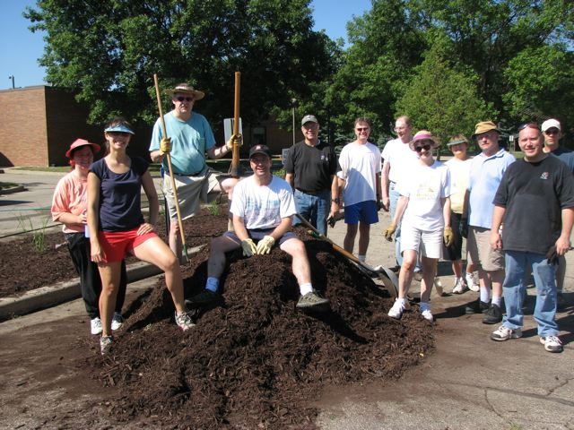
Tables & Chairs
Just a reminder if you need to borrow tables and chairs from the church – all requests are to go through the Board of Church Properties. Also, the white tables will not be loaned out, only the older tables.
Thank you for following the guidelines of the Board of Church Properties.
If you have any questions, please speak with Dale Olson.

VEAP School Supplies Drive
Huge Success!!
Because of your great support for the recently completed school supplies drive, Holy Emmanuel provided VEAP with 100% of the requested items including 30 gift cards of $15.00 each. According to VEAP, this year’s drive was especially important as the business recession has hurt many families with school age children in the Bloomington, Richfield, and Edina area. As an example, needy families requested over 2,200 backpacks from VEAP to help their children start the new school year.
Again, thank you to everyone at Holy Emmanuel who supported the School Supplies Drive. Thank you for your donations of supplies, money, and your prayers for a successful drive.

Call Committee Meeting with MN South
As you recall the Voters Assembly on April 20 approved the Minister of Outreach additional position. Shortly thereafter the individuals listed below agreed to serve on a Call Committee. The group held a number of meetings and completed a SWOT assessment of the Strengths, Weaknesses, Opportunities and Threats facing our congregation. We also received a list of 14 candidates for our position from the LCMS MN South district office. On August 7th we met with David Roth and President Lane Seitz from MN South. At the meeting we presented our SWOT analysis and President Seitz made some observations below:
-  We have an outstanding outreach opportunity with the parents of Open Arms and should work to better understand how to minister to them.
-  The general guidelines Synod and District use for adding another worker is a minimum weekly attendance of 150 and more realistically 200 per week.
-  MN South strongly supports the three churches cooperating on outreach and community service efforts.
-  Merging the three churches is not a good idea. His experience is that 1+1+1=1. Many will leave and what remains will not be strong church.

President Seitz also asked us a series of questions listed below which the council has attempted to answer as noted.

1. Is Holy Emmanuel is accepting of change?
The congregation will accept change if and when the leadership energizes them.
2. Does Holy Emanuel care about and really have a heart for serving the community?
The congregation will develop a concern for service to the community when inspired by the leadership.
3. Why don't our people invite someone to church?
Some members don’t feel spiritually inspired by Worship thus it is difficult for them to rationalize why they should invite someone to worship at Holy Emmanuel.
4. Are we really looking for someone to do the work or are we willing to hire someone to coordinate and direct outreach efforts?

Finally MN South agreed to do the following and meet with us in a month:
1. Contact BRUCE MANSI and ask him to work with us on Harvesters follow up
2. Provide feedback on our Sunday service experience through their secret shopper program.
3. Arrange for a demographic study of our immediate area.

If you have any questions about the above or anything the committee is doing please contact any of the members listed below.

In His Service for the Call Committee.
Ron Reich

Minister of Outreach Call committee

Pastor Starr
John Carlson
Bob Chellew
Carla Crawford
Ray Dolny
Rick Marko
Natalie Mylander
Scott Ramsdale
Ron Reich
Chuck Squires

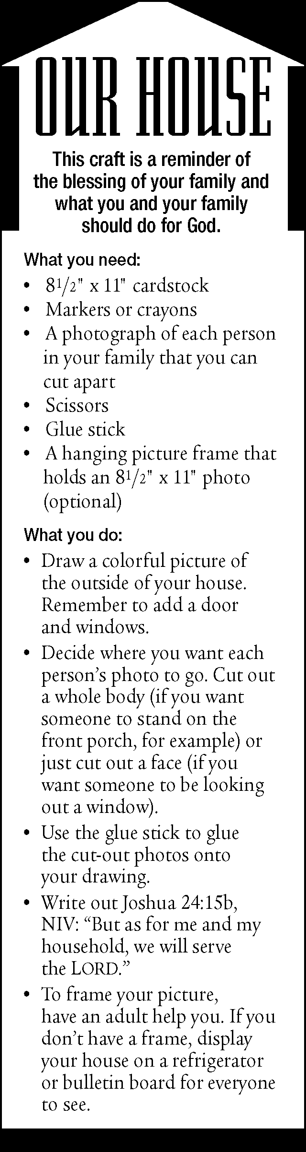

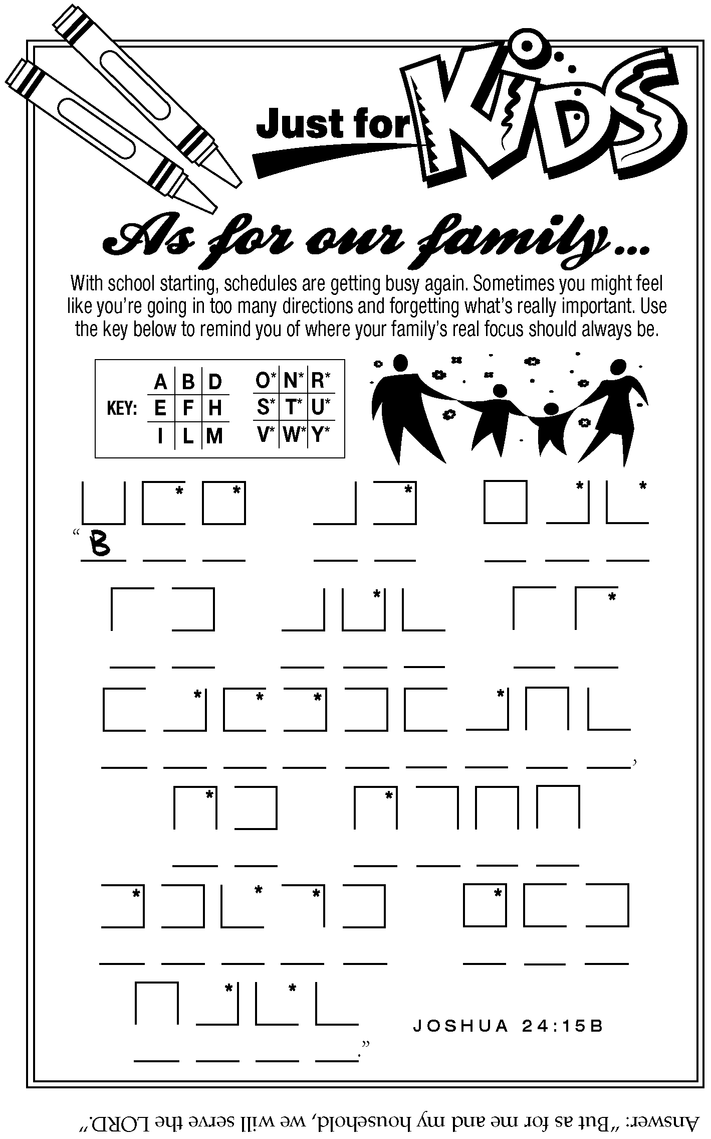

Priscilla Guild

Coffee & Treats!
Beginning Rally Day, Sunday, September 7th, coffee and treats will be available in the narthex following both services.
In order for this social event to occur each week, volunteers are needed to provide the treats and help serve them. A sign up sheet is posted on the board by the flower chart. Thank you!
If you wish to bring your own coffee cup and take care of it, please do so.
If you have any questions, please call Gladys Lossow at (612) 729-8492.



September 4, 5, 6
- September 3 – Sort & Price all items beginning at 9:00 a.m. until it is all sorted and priced.
- September 4 and 5 – 8:00 a.m. – 8:00 p.m.
- September 6 – 8:00 a.m. – 12:00 Noon. Bag sale followed by clean-up.
We will need many men and ladies to help. Watch for a sign-up sheet to work at the Rummage Sale.
Proceeds from the sale will go to Holy Emmanuel and various missions.
This is a church project. The Priscilla Guild only sponsors the event.
If you have any questions, please give Gladys Lossow a call at (612) 729-8492.

