“Precious Blood

“For you know that it was not with perishable things such as silver or gold that you were redeemed from the empty way of life handed down to you from your forefathers, but with the precious blood of Christ, a Lamb without blemish or defect.” ––1st Peter 1:18-19

Several years ago in Oshawa, Ontario, Canada, George and Vera Bajenksi’s lives were changed forever. February 16, 1989. A very normal Thursday morning. The phone rang at 9:15 a.m. "There’s been an accident..." It involved their son Ben. As they approached the intersection of Adelaide and Simcoe Streets near the high school, they could see the flashing lights of the police cars and ambulance units. Vera noticed a photographer and followed the direction of his camera lens to the largest pool of blood she had ever seen. All she could say was, "George, Ben went home –– home to be with his Heavenly Father!" Her first reaction was to jump out of the car, somehow collect the blood and put it back into her son. "That blood, for me, at that moment, became the most precious thing in the world because it was life. It was life-giving blood and it belonged in my son, my only son, the one I loved so much." The road was dirty and the blood just didn’t belong there. George noticed that cars were driving right through the intersection--right through the blood. His heart was smitten. He wanted to cover the blood with his coat and cry, "You will not drive over the blood of my son!"

Then Vera understood for the first time in her life, one of God’s greatest and most beautiful truths... why blood? Because it was the strongest language God could have used. It was the most precious thing He could give –– the highest price He could pay. Through God’s amazing love we were redeemed with the precious blood of Christ (1st Peter 1:18-19). May we never treat lightly nor trample underfoot the blood of God’s Son (Hebrews 10:29). "Amazing love! How can it be? That Thou, My God, shouldst die for me!" (Charles Wesley).

The first two Sundays in October we will be talking about what the Bible has to say regarding the giving of ourselves –– our time, talents, testimony and treasure –– for the work of God’s Kingdom and for the good of our fellow man. No attempt will be made to ‘guilt’ anyone into giving. The giving that pleases God is always motivated by the cross and the empty tomb –– not by budgets or gimmicks.

As with any new year, there are great opportunities before us to extend God’s kingdom. Among those opportunities is the goal, Lord willing, of adding a new staff person who can help us with outreach to the neighborhoods around us as well as assisting us in increasing worship attendance and improving our in-house ministries.

Every member of Holy Emmanuel has something to give. We are the ‘Body of Christ’ and each of you serves a specific function within that body (1st Corinthians 12:12-31). May the good Lord bless you with a spirit of gratitude for the precious blood of Christ as you consider how to give of yourself for the sake of the Gospel and His eternal kingdom.

Serving Him with you,

Pastor Dennis Starr

News from Open Arms
This month we are welcoming Fall with a field trip to the pumpkin patch. We will be learning the Pumpkin Prayer:

The Pumpkin Prayer
Dear God,
As I carve my pumpkin, help me say this prayer:

Open my mind so I can learn about You;
(Cut the top of the pumpkin)

Take away all my sing and forgive me for the wrong things I do.
(Clean out the inside)

Open my eyes so Your love I will see;
(Cut the eyes out in heart shapes)

I’m so sorry for turning up my nose to all you’ve given me.
(Cut a nose in the shape of a cross)

Open my ears so your work I will hear;
(Cut the ears shaped like Bibles in rectangles form)

Open my mouth so I can tell others You’re near
(Cut the mouth in the shape of a fish)

Let Your light shine in all I say and so! Amen.
(Place a candle inside and light it)

We are all looking forward to the Fall Costume Party on Friday, October 24th.
We want to welcome our new staff person – Miss Pam, who has joined us as a “float.”
Come visit us anytime – you are always welcome! God bless!

Working for Him,
Natalie Mylander, Director



Fall Family Costume Party Friday, October 24th
5:00-8:00 p.m.
Holy Emmanuel will host a Fall Family Costume Party on Friday, October 24th, from 5:00-8:00 p.m. There will be fun and games for children and adults of all ages (ages 0–120)!!! Invite a friend to come with you to the party. Please, friendly costumes only.
We could use any donations of novelty toys, 2 liter pop, bags of candy, chips, etc.
If you have any questions, please call Jen Johnson at (952) 888-5116.



Our Kids Choir will be singing for the first time on Sunday, October 5th, at the 10:30 a.m. worship service. Plan on coming to hear them sing their hearts out for Jesus!
The kids thank you for all your support and prayers!

Natalie Mylander

Youth News
Thanks for all your work at the annual car wash!
Our next event will be on Friday, October 24th. We need all your help at our Fall Costume Party. We will be having a lock-in afterwards. More details will be sent out soon.
I pray all our youth will continue to say active in the Lord all year!

Natalie Mylander

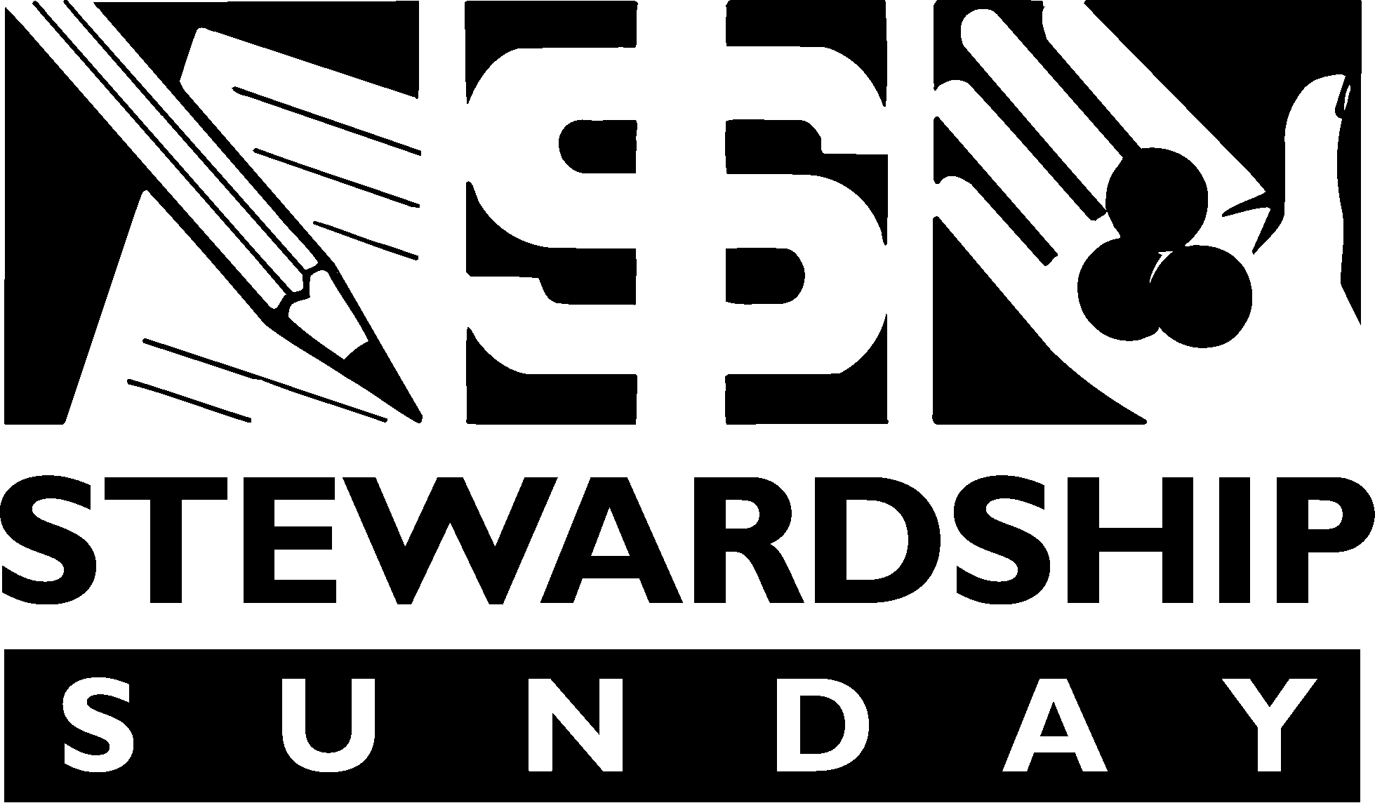
October 12, 2007
(Think and pray about your upcoming faith pledges.)

Shoebox Project
Operation Christmas Child Boxes will be collected once again this year beginning Sunday, October 26th. Please pick up a brochure in the narthex and fill a shoebox to make a child’s Christmas joyful.
If possible, please include a donation of $7.00 by writing a check to: Samaritan’s Purse and including it in the shoebox. Plastic or paper shoeboxes are acceptable.
Volunteers are needed to process boxes at the Operation Christmas child warehouse on Friday, November 28th, from 2:45 p.m. to 6:00 p.m. Please e-mail Sheryl Burkhardt at srburkhardt@aol.com or call at (952) 894-0234 if interested. You must be at least 13 years old to volunteer and after a brief training, we stand for the entire time we volunteer.
Thank you for making Christmas happy for children around the world!

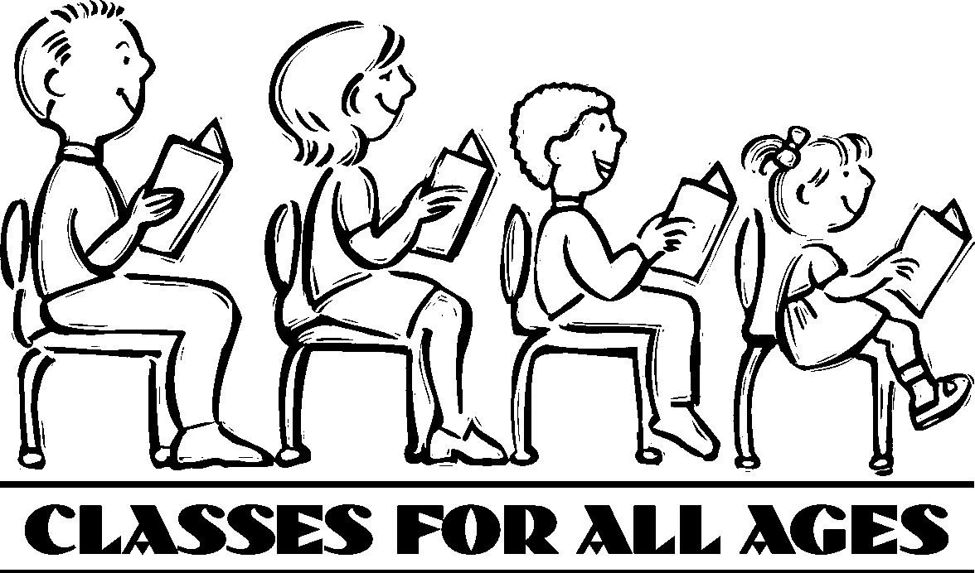

Sunday Morning Bible Study
9:15 a.m. – 10:15 a.m.
- Master Plan (Led by Pastor Starr in the Chapel).
- Growing Through Life’s Challenges (Led by Randy Marko in the Accounting Room).

1st & 3rd Sunday Evenings
5:30 p.m.
Couples in Christ
- Topic to be Announced

3rd Monday Evenings
5:30 p.m. – Supper
6:00 p.m. – Bible Study
- Parenting Class – “Discipline” (Led by Randy Marko)

Tuesday Mornings
10:00 a.m.
- The Book of Joshua (Led by Pat Squires at the Gables Apt. Bldg.)

Wednesday Mornings
9:30 a.m.
- Bad Girls of the Bible (Led by Candy Frein in the Accounting Room)

Thursday Mornings
10:00 a.m.
Begins October 9th
- Topic to be Announced (Led by Chuck Squires in the Accounting Room)

1st Friday Evenings
6:00 p.m.
- Ladies Bible Study
Join us at Denny’s Restaurant in Bloomington. (Led by Natalie Mylander)

4th Friday Evenings
6:00 p.m.
- Youth Bible Study (3rd-12th Graders)
Pizza, Bible Study, Fellowship
Priscilla Guild

Rummage Sale
Many thanks to everyone for donating items, sorting, selling, and especially to all the men who helped with set up, clean up and delivering the remainder of the items to various charities. It is a big job and everyone is appreciated! The sale was a big success!

Noodle Making
Please come and help us make noodles on Thursday, October 9th. We will start at 3:00 p.m., but come when you can. We will be here until 8:30 p.m. or so. Supper is furnished. If you can bring a dish for supper, please let Gladys Lossow know in advance. We need men and ladies to help with this project. It is fun – come and learn to make noodles!

Slovak Smorgasbord Dinner
Bazaar & Bake Sale
- Sunday, November 2nd
- Serving from 11:00 a.m. – 1:15 p.m.
- Cost - Adults - $15.00
Children 12 & Under - $4.00
- Features Slovak and American Foods
- Menu Includes:
Cabbage Rolls
Polish Sausage w/Kraut
Huluski (Dumplings, Cabbage, Bacon)
Pioury (Pasta filled w/cheese and butter or prunes)
Mashed Potatoes & Gravy
Meat Balls
Kolache
Pies
Bread
Coffee, Milk

We need many people to help prepare food, set up and clean up on both days – men and ladies – on Saturday, November 1st and Sunday, November 2nd. Helpers will receive a discount.
Please purchase your tickets ahead of time or contact the church office at (952) 888-2345 to reserve your tickets.
If you have any questions regarding the above events, please call Gladys Lossow at (612) 729-8492.

LWML Fall Rally
The LWML Fall Rally will be Tuesday, October 7th, at St. Michael’s Lutheran Church in Bloomington.
Dinner will be served at 6:15 p.m.
If you would like to attend, please contact Gladys Lossow at (612) 729-8492 for tickets.

A Taste of Ethnic Missions Coming Soon!
Have you ever wondered what happens to the mission offerings your church sends to The Minnesota South District? A portion of it goes to support several Ethnic Missions, providing pastors and mission assistance to various immigrant groups.
Join us for a “Taste of Ethnic Missions” on Saturday, October 25th, at St. Michael’s Lutheran Church (9201 Normandale Blvd., Bloomington). To RSVP, please contact Linda Bradford at the District Office, (952) 223-2157.
The event begins with a cross-cultural worship service at 5:00 p.m. In addition to tastes of authentic ethnic foods, a silent auction features various ethnic items. All proceeds go directly for the support of the District’s ethnic mission work. Tickets are $25/person in advance, and $30/person at the door; children and students are free with the purchase of an adult ticket. Learn about our international mission work
Stewardship Corner

“Blessed to Be a Blessing”
Because God gives, we receive, and then we can give. Interestingly, in giving, we receive even more. Jesus said, “It is more blessed to give than to receive” (Acts 20:35).
God is a loving and giving God. “For God so loved the world that He gave His one and only Son that whoever believes in Him shall not perish but have eternal life” (John 3:16). Through His Word and Sacraments, God provides:
- His grace that gives us this life and life eternal.
- His love that didn’t spare His only Son.
- His forgiveness.
- His victory over sin and death.
God’s Word clearly directs us to use the blessings we receive from Him to bless others. We are blessed to be a blessing. In Christ’s name, we are to clothe the naked, feed the hungry, shelter the homeless, and help the sick (Matthew 25:35-36). God blesses us not only to take care of our needs; He blesses us so that we can use what we receive to bless others. Paul wrote “Therefore, as we have opportunity, let us do good to all people, especially to those who belong to the family of believers” (Galatians 6:10). “You will be made rich in every way so that you can be generous on every occasion, and through us your generosity will result in thanksgiving to God” (2 Corinthians 9:11).
The wonderful thing is that, as God blesses us to bless others, we are blessed again. When we give faithfully and generously, we will hear God’s words, “Well done, good and faithful servant” (Matthew 25:21). As people who are a blessing to others, we will enjoy intimate fellowship with our Father and His Son, Jesus. Is there any greater blessing than this?

Chancel Choir Rehearsals
The Chancel Choir will meet on the following Sundays at 11:45 a.m. in the Sanctuary.
October 12
October 26
You are welcome to join us.

VEAP
(Volunteers Enlisted to Assist People)
Dear Holy Emmanuel:
Thank you so much for participating in the VEAP Back-to-School collection this year. With the help of your congregation VEAP was able to assist approximately 2500 youth in our community with school supplies, backpacks and gift cards.
The Back-to-School program saw an enormous 30% increase compared to the 2007 program. With help from our member churches we were able to serve almost 600 more children and their families. Your continued support and donations give VEAP the ability to respond to the increasing need in our community.

Thank you!
Kristin Hill
VEAP Seasonal Programs/Case Manager

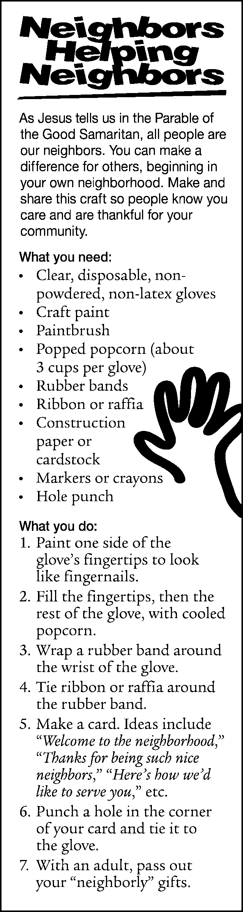

Reformation Polka Service and German Dinner.
The public is invited to attend the annual Reformation Polka Service beginning at 4:00 p.m. on Saturday, October 25th. Chuck Thiel and the Jolly Ramblers Polka Band are the featured musicians during the service. A German dinner featuring Beef w/Brown Onion Gravy follows at 5:15 pm. Tickets, adults $8 and children 10 and under $4, may be purchased in the church office or at the door. The church is handicapped accessible.

Gloria Dei Lutheran Church
3014 McKinley Street NE
Minneapolis, MN 55418
612-781-1989

Lectures on Slovakia
Former Slovak Ambassador to the Unites States, Dr. Martin Butora and his wife, Zora Butorova will be visiting the Twin Cities from October 6th through October 12th. Both will be giving a series of lectures on current events in Slovakia, relations between the U. S., Europe and Slovakia and on the transition to democracy. There will be many opportunities for discussions, questions and answers. Most events are free and open to the public and are being held at various venues throughout the Twin Cities.
For further information contact Don Pafko at (952) 831-1440 or e-mail him at Pafkova@aol.com

